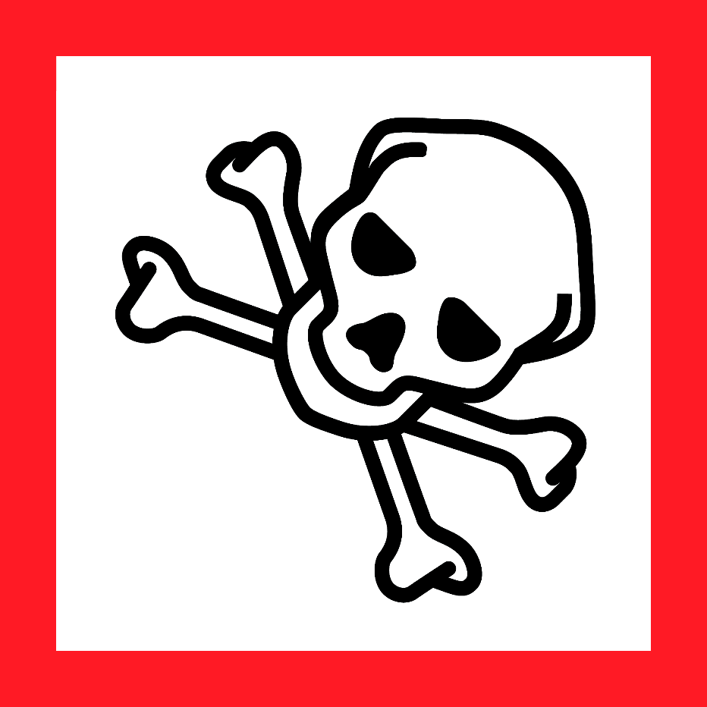    Danger! Contact with Acids Liberates Toxic Gas! |  | Duke OESO Guidelines for Safe Use of  Chemicals which, in contact with acids, LIBERATE toxic gas  Examples: thiocyanates, sulfites, ferricyanides & other  similar Action B compounds  Complete Lab-Specific Safety Information on page 2 | Danger! Contact  with Acids Liberates  Toxic Gas!
Contact with Acid Forms Toxic Gas Guideline
COMING SOON

A Fillable Guideline that can be used to create a laboratory-specific SOP for Chemicals which, in Contact with Acid, Liberate Toxic Gas, is currently under development. Until the guideline is published, continue to follow the Chemical Hygiene Plan, and use the SDS and the blank SOP template* to create a lab-specific SOP for your chemicals that liberate toxic gas when in contact with acids.
*Note – There are several available Duke guidelines relevant for this general hazard class. If there is a relevant guideline for your chemical, use the one linked here instead of the blank SOP Template: PMSF and HF Releasers, Cyanide Salts, and Sodium Azide.

